IT20661410

**Requirement Scenario**

* Customer has Cid(unique),Cus_name,Cus_address,Mobile_no.

Customer can use many mobile numbers.

* Reg_customer is a customer which have Cus_id and Cus_type.
* UnReg_customer is a customer which have nic.
* Customer can views menu.Menu has menu_code(unique),lunch.dinner,dessert,short eats.
* Customer can place many orders.
* Order has Oid(unique),Quantity,O_name,Description.
* Take_away is a order which have waiting_time and No_Of_Parcels.
* Dine in is order which have Table_no and No_Of_Guests.
* Dine in order serves by waiter.
* Waiter has Waiter_id(unique), Waiter_salary,Waiter_age,Waiter_name.
* Many order prepare by many chefs.
* Chef has Chef_id(unique),chef_name,chef_salary,chef_age.
* Manager has Mang_id(uniquea),Mang_name,Mang_nic,Mang_phone.
* One Manager manages many chefs as well as one manager manages many cashiers.
* Cashier has C_id(unique),C_name,C_salary,C_age.
* Cashier can receives a payments.
* Payments has Pid(unique),Amount,Qty,MRP.
* One customer makes one payment at a time.
* When Cashier receiving a payment,system automatically generate a bill.
* Bill has Bill_id(unique),Date,Amount,Other_details and it can generate many Bills.
* Customer gives Feedbacks and Feedbacks has a F_id(unique),Order_details,Order_type,Order_date.
* Possitive feedback is a Feedbacks.
* negative feedbacks is a Feedbacks.
* Restaurant has many tables and table has one Resturant R-id(unique),R_name,R_address,R_phone.

Resturant has many phone numbers.

* Table has T_no(unique),T_type,T_capacity,up_down.
* Customer can setect many table.
* Restaurant is control by one or many managers.Managers has Mang_id(unique),Mang_name,Mang_nic,Mang_phone.

Manager has many phone numbers.

* Manager can manages many Chachier and can manage many chefs.

**EER Diagram**

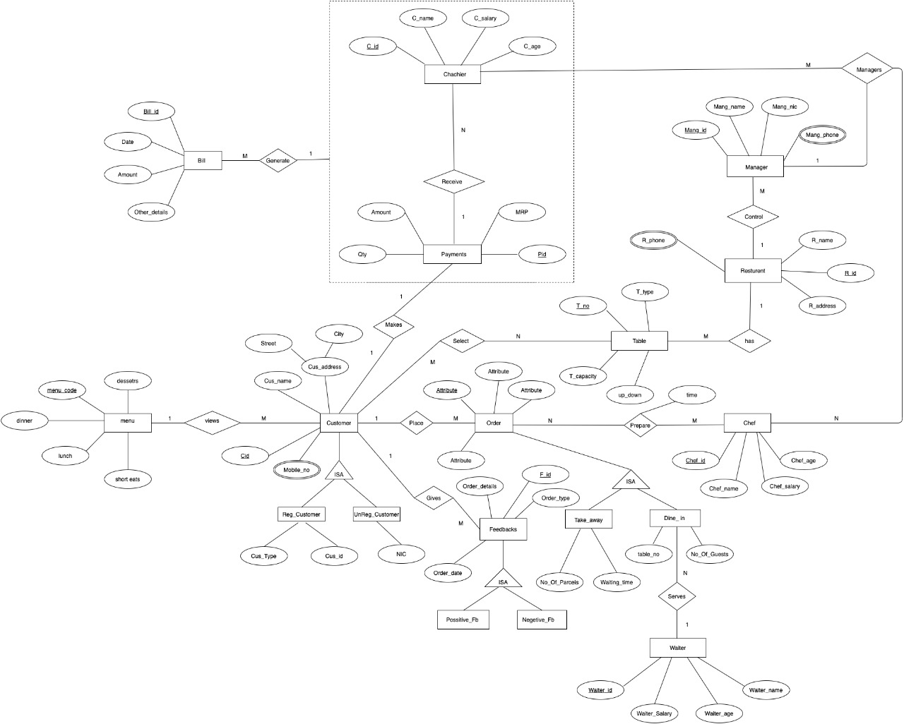

**Relational Relationship**

Option 3

ISA registered customer and unregistered are subclasses in customer class.The relationship must be disjoint and it not allow overlapping.Subclass also have few attributes.

Customer(Cid,Cus_name,Street,city,Cus_Type,Cus_id,NIC,menu_code)

Foreign key(menu_code)references menu(menu_code)

Customer_Phone (Cid,Mobile_no)

Foreign key(Cid)references Customer(Cid)

menu(menu_code,dessetrs,lunch,short eats,dinner)

Option 1

ISA Take away and Dine in are the subclasses in Order class.Dine in order have relationship with another entity (Dine in Order is served by waiter.)Therefore cannot use option 3 and option 4,Order must be either Take or a Dine in order.There annot be any partial constraints.

This option works for all constraints disjoint,overlapping,total and partial.

Order(Oid,Quantity,Order_name,Description,Cid)

Foreign key(Cid)references Customer(Cid)

Take_away(Oid,Waiting_time, No_Of_Parceis)

Foreign key(Oid)reference Order(Oid)

Dine_in(Oid,Table_no, No_Of_Guests,Waiter_id)

Foreign key(Oid)reference Order(Oid)

Foreign key(Waiter_id)reference Waiter(Waiter_id)

Waiter(Waiter_id,Waiter_Salary,Waiter_age,Waiter_name)

Chef(Chef_id,Chef_name,Chef_salary,Chef_age,Mang_id)

Foreign key(Mang_id)reference Manager(Mang_id)

Prepare(Oid,Chef_id,time)

Foreign key(Oid)reference Order(Oid)

Foreign key(Chef_id)reference Chef(Chef_id)

Table(T_no,T_type,T_capacity,up_down,R_id)

Foreign key(R_id)reference Resturent(R_id)

Select(T_no,Cid)

Foreign key(T_no)reference Table(T_no)

Foreign key(Cid)reference Customer(Cid)

Resturent(R_id,R_address,R_name)

Resturent_Phone(R_id,R_phone)

Foreign key(R_id)reference Resturent(R_id)

Manager(Mang_id,Mang_name,Mang_nic,R_id)

Foreign key(R_id)reference Resturent(R_id)

Manager_ManagerPhone(Mang_id,Mang_phone)

Foreign key(Mang_id)reference Manager(Mang_id)

Chachier(C_id,C_name,C_salary,C_age,Mang_id,Pid)

Foreign key(Mang_id)reference Manager(Mang_id)

Foreign key(Pid)reference Payment(Pid)

Manages(Chef_id,C_id)

Foreign key(Chef_id)reference Chef(Chef_id)

Foreign key(C_id)reference Chachier(C_id)

Payment(Pid,Qty,Amount,MRP,Cid)

Foreign key(Cid)reference Customer(Cid)

Bill(Bill_id,Date,B_amount,Other_details,C_id)

Foreign key(C_id)reference Chachier(C_id)

Option 3

Create a single relation including attributes of the superclass as well as attributes of all sub classes.The specialization/generalization relationship

Feedbacks(F_id,Order_details,Order_type,Order_date,Cid)

Foreign key(Cid)reference Coustomer(Cid)

**Query**

1. Query 01

Select c.Cus_name,p.Amount,p.Qty

From Customer c,Payment p, Cashier c

Where c.Pid = p.Pid

Group by Cus_name

Having max (Amount) > 1000

1. Query 02

Select c.Cus_name

From customer c, Payments p, Cashier ch

Where Customer c,Pid AND p.Pid = ch.Pid IN (Select Pid

From Cashier

Where C_name = ’Dilshan’)

Function/procedure

This function is created to get number of customers from a given city.

create function fn_getCustomerCount (@city varchar( (30) ) returns int

as

begin

declare @count int

select @count=count(*)

from Customer

where city = @city

return @count

end

Declare @cnt int

exec @cnt = fn_getCustomerCount ‘Matugama’

print @cnt

Triggers

create trigger CheckCash_Salary

on Cashier

for insert, update

as

begin

declare @cashSalary real, @mangSalalary real

declare @mangID int

select @cashSalary = C_salary , @mangID = Mang from inserted

select @mangSalary = e.salary from Manager m , Cashier c

where m.Mang_id = c.C_id and m.Mang_id = @mangID

if @cashSalalary > @mangSalary

begin

print’Cashier Salary cannot exceed manager salary’

rollback transaction

end

end